**Name : Asad Gulshair**  Roll NO: 5121115

**Heart Attack Detection Model:**

**Performed steps:**

1-Data Preparation

* Data Cleaning
* Fill miss value
* Encode categorical variables using label encoding
* Data Visualization

2- Model Training with 80% and 70% train data

3- Model applied and check accuracy

**Data:** 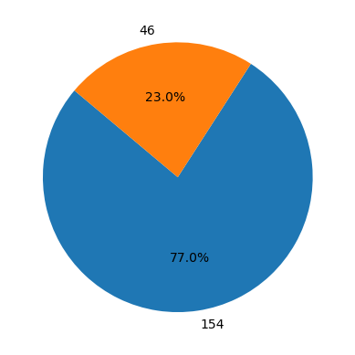

In this model we have:

no 154

yes 46

In this model we have 154 person with no heart attack and 46 person with heart attack. Now based of this output and other variables we will apply multiple algorithms and check the accuracy rate.

# 1-Logistic regression model

# 2- KNN model for Data

# 3- Random Forest Algorithm

# 4- Now we will Use Decision Tree for model

# 5- Naive Bayes algorithm

**Test and train size:**

1-First we used the 30%test size and 70% train size

2-We used 20% for test and 80% for training

**Results:**

|  |  |  |
| --- | --- | --- |
| **Models:** | **Accuracy with 80% train size** | **Accuracy with 70% train size** |
| Logistic regression | 0.825 | 0.8333 |
| KNN model | 0.75 | 0.8333333333 |
| Random Forest Algorithm | 0.825 | 0.766666666 |
| Decision Tree | 1.0 | 0.76666666 |
| Naive Bayes algorithm | 0.8 | 0.86666666 |
|  |  |  |